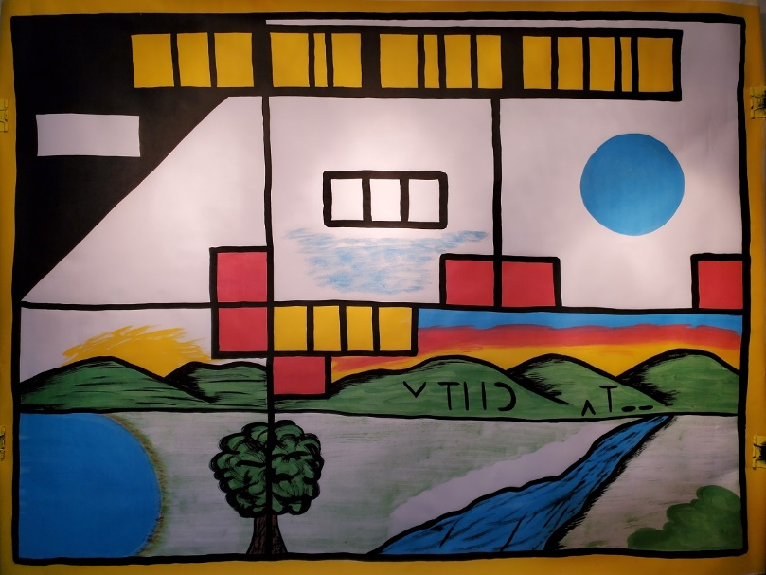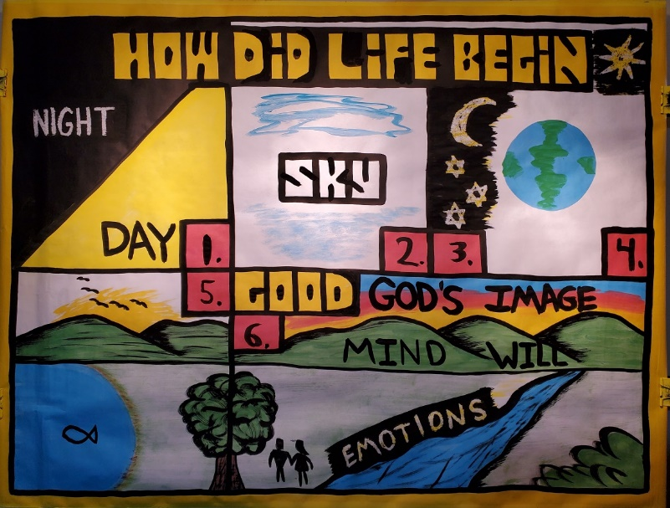

Creation Series
Day 2: Creation and God Creates Man (Genesis 1-2)
Note: When you see typing in “CAPS” and bold like this, make sure you are drawing on the sketch-board as you teach
Main ideas!

- God created everything good. Meaning, God created a world with no death.
- God made man in His image. Only people were made to know and have a relationship with God.

Introduction: Probably one of the most important questions to ask is:
HOW DID LIFE BEGIN? (Draw in title). Why is the earth here? Why are there so many animals? How did people get on the earth? And, what is the meaning of life? Today, we are going to find out!

Day 1: Light

- In the beginning there was only God. God had no electricity or light. Out of nothing, God spoke and said:
  - “Let there be light...” (DRAW IN YELLOW)
  - God called the darkness NIGHT, (go over in wax) and the light DAY
  - When God saw what He made, He saw that it was GOOD
  - God can speak because He is a person
  - This one day 1

Day 2: Water and air

- God separated the WATER (DRAW IN WATER ABOVE)
- God also created AIR or sky.
- Aren’t you glad? Everyone take a big breath!
- This was day 2

Day 3: Land and vegetation

- God made the dry ground out of the water.
- God chose to form the water into a sphere.
- Out of the water, God formed dry LAND (DRAW Green land, upper right hand box)
- Now the earth has just land and water. What is missing?
- God made all kinds of different TREES (lower left box)
- God made different FLOWERS and fruit (left box)
- God saw what He made was good.
- This was day 3

Day 4: Sun, moon, and stars

- What do plants need to grow? (upper right hand box)
1.) God put the SUN in the sky to give life to the plants, seasons, etc.
2.) God put the MOON in the sky to give light at night.
3.) God put STARS in the sky? How many stars are there? God has given all of them names (Psalm 147)
- God saw what he made was good.
- This was day 4.

Day 5: Birds and sea animals

- What is missing so far in God’s creation story? Fish and birds (lower left box).
- Draw in BIRDS in the sky
- Draw a FISH TAIL in the water.
- Draw in a SHARK FIN in the water.
A). Ask the kids: “What do sharks eat?” They will say other fish or people. Here is a great time to explain God’s good and perfect world. Act this out; say: “Let’s pretend you are a momma fish, and you are swimming along with your baby fish. And all of a sudden (use a loud voice) a shark comes and rips the baby fishes’ head off!! If you were that baby fish, is that good? If you were the momma fish, is that good? No.
- God created everything good. In the beginning when God first created life, there was no death. Animals ate only plants (Genesis 1:29-31).
- This was day 5

Day 6: Land animals and man

- GOD spoke and created the thousands of different kind of land animals.
1.) Draw some SHEEP (male and female)
2.) Draw some TURTLES (male and female)
3.) Draw a smiley face on the DINOSAUR. (Dinosaurs are land animals, so God created them on day six. Plus, they were created good, so they were not man‐eaters in the beginning).

- “Then God said, ‘Let us make man in our image, after our likeness…” (Genesis 1:26)
- God took some of the ground, formed it into the shape of a man, breathed life into the ground, and man became alive (Genesis 2:7).
- He was given the name Adam (Genesis 2:17, 20-21).
DRAW IN A HUMAN STICK FIGURE for Adam.
- Adam is not an evolved monkey.
- Adam was told to manage the Garden of Eden he was placed in. (Genesis 1:26-30, 2:8-9,15-17)
- Adam was told he could only eat vegetables and plants.
(1:29-30) Adam never went to McDonald’s to eat hamburgers.

- Adam is not an animal, but made in the Image of God. What does it mean to be made in God’s image?
- Adam has a MIND. Adam and people can think and talk. Animals do not get up in the morning talk about their day.
- Adam has a WILL. Adam can think and chose to listen to God or not listen to God.
- Adam has EMOTIONS. Adam can feel angry or sad.

- So, can God talk? Yes, because we can talk. God made us a little like him.
Can God get angry or sad? Yes, because we have emotions. Can God make decisions? Yes, because we can make decisions. God made humans in His image. Humans are made to be a little like God.
1). God made us to have a relationship with Him.

- God told Adam to name the animals (Genesis 2:20).
1). But there was no animal he could have a relationship with. He needed a companion.

- God put Adam into a deep sleep, and God performed the first surgery by taking out Adam’s rib, and making a woman out of Adam’s rib. Adam was made out of the ground. But the woman was taken out of man.
- Eve was Adam’s wife. DRAW IN A FEMALE STICK FIGURE
- Eve was made in God’s image as well (Genesis 1:27).
- God performed the first marriage (2:24, 25).

- They were both naked and had no shame.
1). This concluded DAY 6

Conclusion: This how God created the universe, the earth, and all life. Also, God didn’t create the world evil. God created the world good.
Tomorrow we will find out what happened to God’s perfect world.

