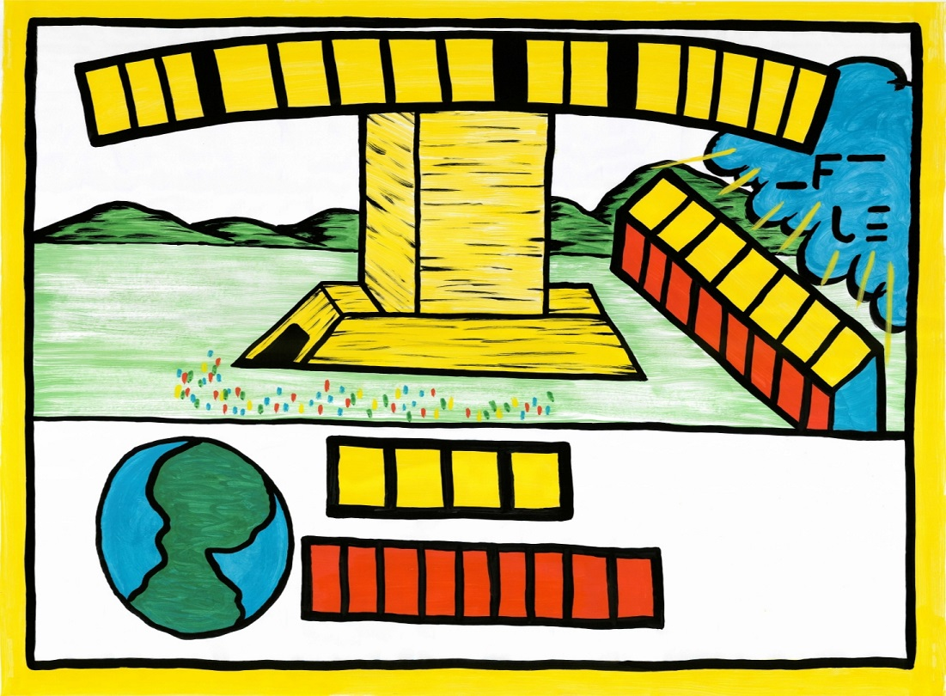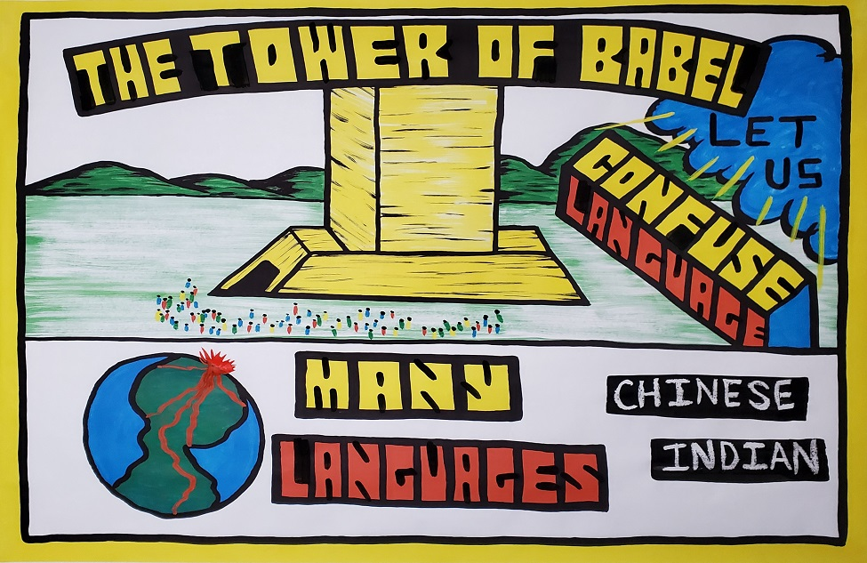

New Tribe Mission Outline Numbers

F.

G.
The Abraham Series
Day 2: The Tower of Babel Sketchboard title: “The Tower of Babel” Text: Genesis 11:1-9

Open Air Campaigners Outline

Introduction: Have you ever wondered why people speak different languages, look different, and live in different parts of the world? Well, not only is the Bible a spiritual book, but it is also a book of history.
Therefore, the Bible tells us the answers to these questions. Let’s begin…

In the years after Noah and his sons left the Ark, they had many children people again began to fill the earth. God told them to spread out throughout the earth. Unlike today, there was only one language (Genesis 11:1).

- Draw in the people around the tower.

Soon after the Ark landed on Mt. Arat, Noah’s children begin to have children. Eventually, the grandchildren of Noah began to turn away from God and became very sinful. Instead of spreading out over the earth like God told them, they chose to stay together. They decided to build a big tower that reached into the sky in order to make a name for themselves (Genesis 11:3-4).

- Draw in the word “Tower” in the title.

(It doesn’t say this in the Bible, but historians believe these types of large tall buildings were used for worshiping the Sun and stars, and for pagan sacrifices.) The people forgot God and disobeyed Him by worshiping different gods that they had made up. God could not allow this. God came down and said, “…let us go down… (Genesis 11:7).

- Draw in “Let us” ( in the cloud)

Ask the kids, “When God says 'Let us', who is he talking about? Answer: The Father, the Son, and the Holy Spirit.

Why did God come down to where the people were?
Again, God said, “Come let us go down and confuse their language…” (Genesis 11:7).

- Draw in the box “Confuse Language”

Why would God come down to confuse their language? (Wait for the kids to answer the question)

If God made people start speaking different languages, they would not be able to communicate.

Here is a one-person skit to act out in front of the kids.

Stand up on a chair in front of the kids and say,

“Hey Bob, hand me up another brick!”
Get down off the chair and back away from the chair, look up and start talking in a funny way to mimic a foreign language. Get back up on the chair and say, “Bob, what happened to you! I can’t understand a word you’re saying!” Look confused and turn the other way and say,
“Hey Steve, hand me up a brick, Bob over there has been in the sun too long, I can’t understand a word he is saying!”
Get down off the chair and back away from the chair. Have the “Steve guy” talk in some weird language like they do in the Star Wars movies. Carry this on as long as you like. The kids love it.

Because the people could not understand each other, it sounded like babbling. What does babbling mean? It's like when you listen to someone and it sounds like this (move your finger up and down your lips) babel, babel, babel. (Genesis 11:9)

This is why the Bible calls the tower the Tower of Babel.

- Draw in and finish the title: “The Tower of Babel”

So where did all the different languages we have today come from? God and the Tower of Babel. No longer was there just one language in the world, but many languages.

Lower Box
H. 6. Draw in the words: “Many Languages.”

Not only did God create new languages because of their sin, but God also made the people spread out throughout the world. The people that spoke the same language and could understand each other decided to live together and the different groups eventually spread out into the world. This is how different cultures were established.

- Draw red lines throughout the earth.

This is why we have so many different languages and cultures today.

- Paint over in candle: Chinese

- Paint over in candle: Indian

As well as many different languages and cultures like those in Africa.

So, why are their different languages and cultures today? It is because of people’s sin and God’s judgement on them a long time ago. Again, we see that when mankind rebels against God, God does not take it lightly. There is always a consequence for sin.

Also, we can look to God’s Word to understand God’s world.

END

Main Goal:
God is in control of all things. No one can change God’s mind or plans. When He says He wants something done, it will get done. If people do not obey, there will be judgment. Once again, the Bible has given us the answers to some of the questions we many have such as: Why are there different languages, skin colors, and cultures in the world?

