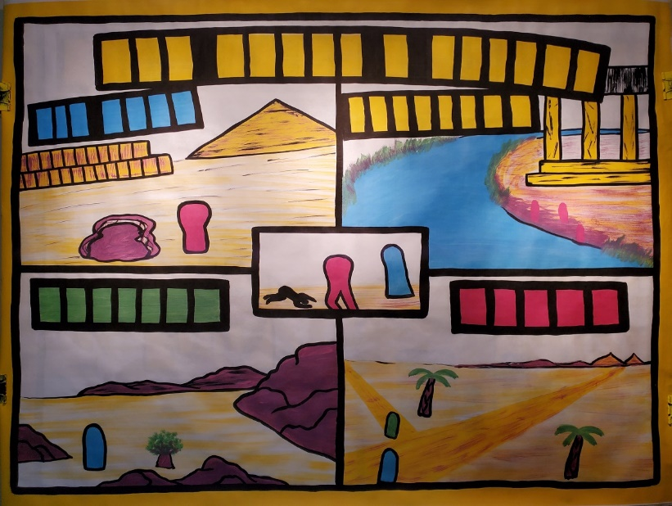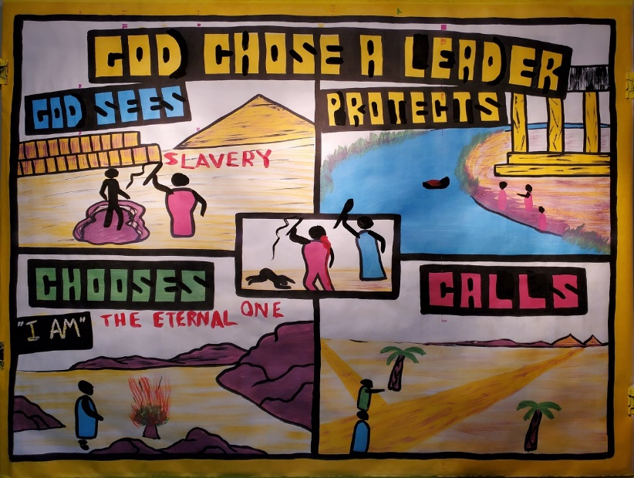

The Moses Series Day 1: The Call of Moses
Sketch-board title:
"God Chose a Leader"
Text: Exodus 1-4

Introduction: Have you ever been asked to do something you didn't want to do? Yes we all have like taking out the garbage, helping a brother or sister, cleaning the house etc.

Today, we are going to learn about how a man, who at first didn't want to obey God, did obey God and the world was changed because of it. What would you do if God told you to do something you didn't want to do?

TOP LEFT BOX (EXODUS 1)

When Joseph was prince of Egypt, the family of Joseph came to stay with him permanently. About 350 later, now the Israelites increased to well over a million people. During that time the Egyptians took advantage of them by making them their slaves

- Draw in the word "Slavery"

The Egyptians were cruel taskmasters and made them work hard.

- Draw in an Israelite in the mud hole

The Egyptians made the Israelites make bricks to build their huge buildings. Some even think it was the Israelites during this time that help make the Pyramids (point to the Pyramid)

- Draw in the Egyptian soldier

If the Israelites did not work well or they became weak, they would be beaten and treated cruel with whips. The king of Egypt became so cruel, that he made the Israelites try to make bricks out of mud with no straw. This is quite hard! Plus, he made them work twice as hard

Then the real persecution came. The pharaoh made a rule that
Every male child born to an Israelite home would have to be thrown into the river Nile and die! How terrible.

Remember, the Israelites were God's chosen people. Did God care? What was God going to do? Always remember that God is Spirit, therefore God is everywhere. Because God is everywhere…
- Draw in the words "God Sees"

Because God sees everything, God was not going to let this go on, so, God had a plan. God's plan was to choose a leader to set his people free. Satan's plan was to destroy the Jews so the promised deliverer would not be born

TOP RIGHT BOX (EXODUS 2)

During the time of this rule by the King to kill all the baby boys born to Israelite families, a special baby boy was born.
The boy's mother could tell that the baby was different and special. In faith, she made basket out a papyrus plants and covered it with tar. She then placed the baby in the basket placed it along the reeds of the Nile River.

- Draw in the basket by the reeds in the river

Pharaoh's daughter happened to be taking a bath in the Nile River at that time along with some of her attendants and saw the basket

- Draw in the women in red down by the river (head, hair, arms)

Pharaoh's daughter saw the basket, and in curiosity asked one of her attendants to go and get the basket

- Draw in the lady in the water getting the basket

When the basket was brought back to Pharaoh's daughter, she opened the basket and saw the baby. Even though the baby was not an Egyptian baby, Pharaoh's daughter felt compassion on the child and wanted to keep him. She even sent for an Israelite woman to nurse the baby. And whom did they find, the baby's mother! What an amazing story!

After the child got a little older, Pharaoh's daughter took the baby in her house as her own and named him Moses. This baby Moses, would be the one in whom God would chose to lead the Israelite people out of slavery.

Because God had a plan to deliverer his people, and someday sent a Savior or deliverer from the Israelite people….

- Draw in the words "God Protects"

MIDDLE BOX (EXODUS 2:11-25)

As Moses grew up as an Israelite in the home of the Pharaoh, he knew he was special and that God had a plan for him. Moses thought that if the Israelites saw him as a strong deliverer, they might follow him.

Taking matters into his own hands, Moses one day saw an Egyptian soldier beating a Hebrew slave

- Draw in the soldiers head, arms, and whip

Looking around and seeing that no one was looking. Moses killed the Egyptian

- Draw Moses killing the Egyptian (head, arms, sword, blood)

Shortly after, Moses found out that people were watching.
Instead of thinking of him as a hero for killing the Egyptian, they were mad. Even Pharaoh the king found out about Moses murdering the soldier and wanted him dead. In fear, Moses left Egypt and hid out in the deserts of Midian to become a Shepherd.

What does this tell us about Moses?

Was Moses a good person or was Moses a sinner?

- Draw in the word "sin"

Good people don't kill others. Moses was a sinner like the rest of us (Talk about sin here as much as you want)

God wasn't going to choose Moses because he was such a good person. God says there is none who are good. If God chooses someone, it is out of God's mercy and for His glory, not because God sees anything good in us.

BOTTOM LEFT BOX (EXODUS 3)

Some time later, Moses was out tending his flocks he saw a bush on fire.

- Draw in Moses (head and arms) next to the bush

- Draw the bush on fire

When Moses got to the bush, the bush was not on fire at all, but God in a symbol of fire was in bush!

God spoke to Moses and told him not to come any closer because the place where he was standing was holy ground because God was there. To teach Moses He was Holy, God made Moses take off his sandals

- Draw in sandals in front of Moses

Taking off his sandals was also a sign in those days of being a slave. If a slave entered into a place where a man had authority, the slave had to take off his sandals as a sign of submission. So, right away God was teaching Moses that He was Holy, Moses was not because he could not come any closer, and, God was the boss, not him

God also talked to Moses and said that He was the God of Abraham, Isaac, and Jacob. It was the God of history, the God of Israelites and now sought out Moses, why?

God began to tell Moses how he has seen the suffering of His people and was about to deliver them. How?

God had made a choice…

- Draw in the word "chooses"

God said to Moses, "I am sending you to Pharaoh, to bring my people the Israelites out of Egypt." Exodus 3:10

Who was Moses to be? In God's time, Moses was going to be the one to go back to the Pharaoh and demand that the Israelites be let go as slaves and leave Egypt.

Moses was God's man…

- Draw in the title: "God Chose a Leader" Moses was scared. Wouldn't you be?
Moses knew that Egypt had many different gods, not the God of Abraham, Isaac, and Jacob. He was also worried that the Israelites would accept him. So, he asked God, "What is the name of the God that is telling the Egyptians to let the Hebrew people go?"

- Paint over the words in black: "I AM"

Exodus 3:14 "God said to Moses, "I AM who I AM. This is what you are to say to the Israelites. I AM has sent me to you." He is the God of your fathers, Abraham, Isaac, and Jacob.

What does the name I AM mean? It is one of greatest names God has. It is a name that describes Him as above all gods and self-made deities. The name I AM means…

- Draw in "The Eternal One"

God is saying to Moses that He is the only One who was there in the beginning before there was time, light, land, animals, and people. Who was the one who was there in the beginning? God. That's right. There is only One God, and the true God has to be great enough to never have a beginning, and never have an end. This is the God of the Bible, the God of history, the I AM. Amazingly, the Savior or the Deliverer that will come from the Israelite people will use this name on his lips again, calling Himself the "I AM" (John 8:58).

Despite the greatest of God, Moses fought with God on going back to Egypt. It was a job he didn't want to do. Thankfully he obeyed God, and the world has been changed because of his obedience.

To make things easier on Moses, God said He would also call another man to help him…

- Draw in the word "Calls"

God had called his brother Aaron on the same mission. They met together…

- Draw in Aaron and Moses on the road that leads to Egypt

They went back to Egypt to meet with the Israelite elders. Just as God said, the Israelite leaders agreed that God had spoken and Moses was the leader God had chosen to go the Pharaoh to say, "Let my people go!"
Will Pharaoh listen? How will God get the Pharaoh to listen? Tomorrow we will find out.
END

Themes to Communicate in this Lesson

- God is all knowing and powerful
- God is Holy
- Only God can deliver man from bondage
- Man is sinful

O p e n A i r C a m p a i g n e r s • PO Box D • Nazareth • P A 18064
Phone: (610) 746-0508 Fax: (610) 746-0509 Email: usa@oaci.org Web: www.oacusa.org

