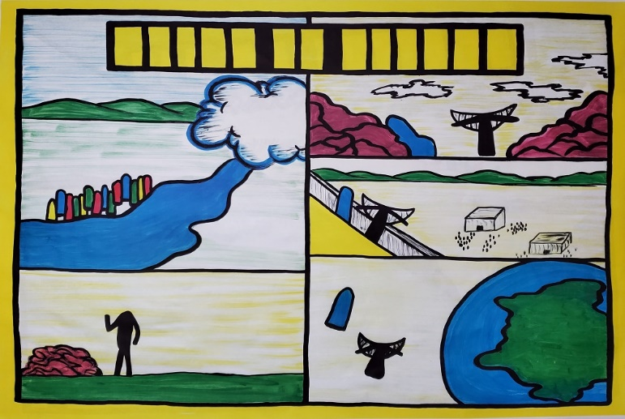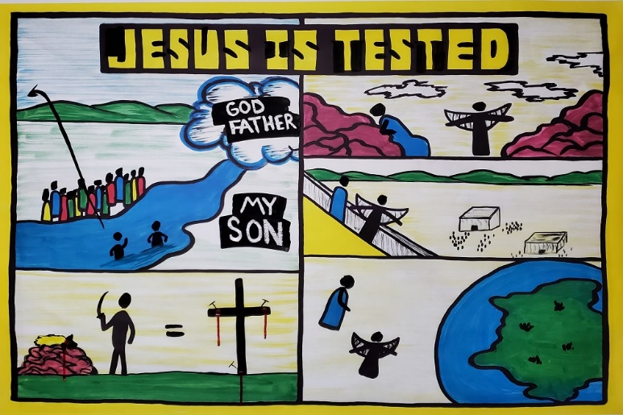

The Early Life of Jesus

Day 2: Jesus’ Baptism and Testing

John 1:19-34 / Matthew 3:13-4:1-11
Note: When you see typing in “CAPS” like this, make sure you are drawing on the sketch-board as you teach
Introduction: Have you ever been tested before? Like taking a math test, or a coach on a soccer team seeing how many laps you could run? Testing is hard, and Jesus in today’s lesson is going to be tested to see if He really is the Son of God who came down from heaven.

- God chose a man named JOHN THE BAPTIST to tell others that Jesus was coming (draw John in the water).

- As a sign that people wanted God’s forgiveness and were waiting for Jesus to be revealed, PEOPLE CAME DOWN TO THE WATER (draw heads on people down by the water) to be baptized.
  - Water does not forgive your sins
  - Being baptized simply was a public way of saying to everyone that they wanted God’s blessing on their lives.
  - People would confess their sins before they were baptized (Describe what confession means: to acknowledge).

- Some in the crowd were religious leaders called PHARISEES (draw heads on the red stick figures).
- They were watching John and became jealous of John because of his big crowds.
- John was very bold and pointed at the Pharisees and told them to

REPENT!
- The Pharisees, like many people thought they were too good to be baptized. Many people think they are good enough for Heaven, but this is lie. God says no one is good (Romans 3:10).

- Soon after John started baptizing, Jesus appeared to the crowd and to John. John shouted in front of everyone, “Look! The Lamb of God who takes away the sin of the world.” Baptism doesn’t take away sins, John was saying, “Look everyone, here is Jesus, he will take away your sins.” By why a lamb?
- A long time ago, people use to take innocent male LAMBS AND PUT IT ON AN ALTAR.
- A man would TAKE A KNIFE and kill the lamb. 3). Why?
Before Jesus, people would bring a lamb to God and say, 4). “God, you punish people who sin. Let the death of this lamb
take my place so I don’t have to.”
5). So, what John was saying is Jesus will some day die like a lamb to die for our sins. DRAW IN THE = SIGN, AND THE CROSS

- Jesus came to John the Baptist and said he wanted to be baptized (DRAW JESUS IN THE WATER).
1). Jesus was not a sinner. But like others, Jesus was telling everyone publicly that He was trusting God too.

- When Jesus came up out of the water, everyone heard a loud voice from Heaven. It was GOD THE FATHER (paint over the wax with black).
- God the Father spoke and said to everyone: “This is MY SON, with whom I am pleased.”
- Jesus is not just a normal man. Jesus is God the Son in a human body.
- God cannot lie. The baptism of Jesus was so important because God the Father publicly made an announcement that Jesus is the Son of God!

Transition: “How do we know this is true? How do we know Jesus is really the Son of God? If I told you I could slam dunk a basketball, the only way to know is to give me a basketball, put me on basketball court and test me to see if I could slam dunk. Well, God the Holy Spirit is going to test Jesus now to see if He really is the Son of God. If he passes the test, we all know He is the Son of God.”

- Write in the title: JESUS IS TESTED
1). The Holy Spirit led Jesus outside of the city into the hot desert

DRAW ARROW FROM JESUS INTO THE MOUNTAINS

- Jesus was going to be given a number of tests. The first test was to be given no food for forty days, but only water. In the hot desert Jesus could not eat. For forty days Jesus obeyed God the Father and did not eat (side note: It has been documented that people can go 30 to 50 days drinking water but no food).

- Jesus as a human being is now starving, close to the point of death (DRAW JESUS LAYING UP AGAINST A ROCK).
1). Remember, Jesus is both God and man together.

- The second test comes: SATAN himself appears, and begins to lie and say things to make Jesus doubt God the Father.
- Satan told Jesus to use his authority and make the stones bread
so he could eat. He was really saying, “God won’t help you, he has forgotten you. It’s okay to disobey, you have to eat, look at you.”
- If Jesus disobeyed His Father, he would sin.
- If Jesus became a sinner, he could not rescue us because he too would have to be punished by God.
- Jesus used scripture and resisted the devil (quote: Matthew 4:4)

- Satan took Jesus to the top of the temple (a 450 ft. drop) DRAW IN THE HEAD OF JESUS AND SATAN).
- Quote loosely: Matthew 4:6
- Satan was basically saying, If you trust God so much jump off the temple, an angel will catch you (using the Bible, but twisting it).
- God does not have to be put on trial. We are not to test God.
Jesus said: quote: Matthew 4:7
- Jesus corrected Satan’s false interpretation of the Bible with a correct interpretation of the Bible.

- Satan took Jesus somewhere and showed him many kingdoms of the world (DRAW IN THE HEADS OF JESUS AND SATAN).
1). Satan has control of millions of people through lies and false religions 2). Satan told Jesus to bow down and worship me, and he would let
go of his control over millions of people.
- Satan was now playing on Jesus’ compassion. One act of bowing to Satan, would save millions of people.
- But remember, it was predicted by John the Baptist that Jesus would save millions of people by dying for their sins. Bowing to evil was not God’s way.
5. Jesus told Satan: Quote: Matthew 4:10

- Satan finally left. Jesus had won the battle. Good angels from heaven came and “ministered” to him, or nursed him back to health with probably food. Jesus passed the test.

Conclude with the main point of the lesson:

Jesus was told by God the Father that He is the Son of God. And then, he was tested to see if he really was the Son of God. He was brought to the lowest point of human existence, and then tempted by Satan himself. How many of us could be brought to the point of starvation, and then have Satan come and mess with us to sin, and pass the test, and don’t disobey God? Because Jesus is both God and man, his human body could be brought to the point of starvation, but because he is the Son of God, he loved God the Father and trusted in the Bible as the authority. We couldn’t be brought that low, and pass the test, because we are only human, and sinners. But Jesus passed the test, didn’t sin, and trusted God the Father in the test showing Himself to be truly the Son of God.

