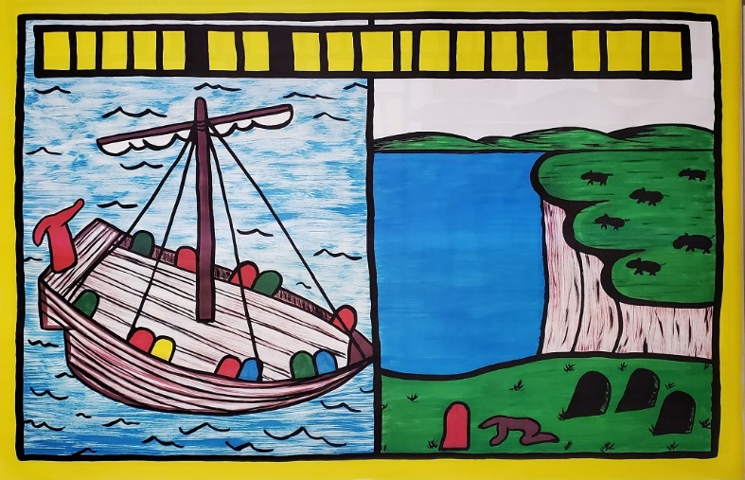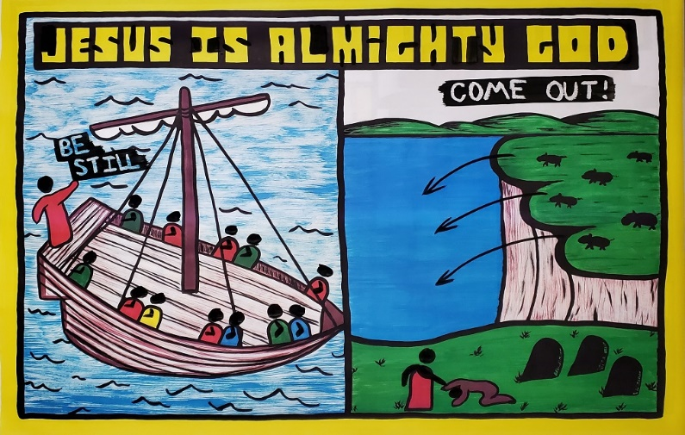

The Early Life of Jesus

Day 4:
Jesus Calms the Storm &
Heals the Demon-possessed man
Mark 4:35-5:1-20

Note: When you see typing in “CAPS” like this, make sure you are drawing on the sketch-board as you teach

Introduction: If you were Jesus, what kind of things would you do to show your friends the disciples how powerful you were?

Paint in JESUS in the title. Jesus shows us in the story today that because He is God, He can do ANYTHING and has power over ALL THINGS.

One day after Jesus finished teaching the crowds and healing people, it was evening and Jesus told the crowds to go home. Jesus and His 12 disciples got into a boat and started out for the other side of the Sea of Galilee. All of a sudden a ferocious storm started on the sea.

- Paint BLACK HEADS onto the 12 disciples in the boat.

Tell the story in your own words…

… The disciples woke Jesus up and said, "Teacher, do you not care that we are about to drown?" Jesus stood up...

- Paint on JESUS’ HEAD in black...

..and told the wind and the sea to quiet down. Jesus said, "Hush, be still!" The wind immediately stopped and the sea became perfectly calm. Why did the wind and sea obey Jesus?

- Complete the title: (Jesus) IS ALMIGHTY GOD

Tell the story in your own words…

The disciples were filled with awe after Jesus performed this miracle and whispered among themselves saying, "Who then is this, that even the wind and the sea obey Him?"

This is probably the most important question you will ever ask yourself. What you believe about Jesus will determine whether you go to heaven or not.

Transition to Jesus meeting the demon-possessed man.

Jesus and His 12 disciples made it to the other side of the Sea of Galilee. They pulled the boat up onto the land. Just as Jesus was getting out of the boat a demon-possessed man ran out from the graveyard to talk with Jesus…

D. Paint THE HEADS ON JESUS AND THE DEMONPOSSED MAN

Tell the story in your own words…

Jesus said to the demons inside the man… E). Paint over in wax with black: COME OUT!
The demons begged Jesus to send them into the pigs. Jesus gave His permission. So all the demons that were in the man went into the herd of pigs. Just then the entire herd of pigs about 2,000 of them jumped off...

F). Take the black paint and DRAW ARROWS of the pigs jumping into the sea

Tell the story in your own words…

This man was set free from the control of Satan and his demons by the power of the Lord Jesus. This man no longer had to do what the demons told him to do. He was now under the authority of God. Jesus set him free from Satan's power. Could this demon-possessed man free himself from the power of the demons? No, only God could do that!

Conclusion: Jesus is Almighty God because He can control the weather and even demons listen to Him.

