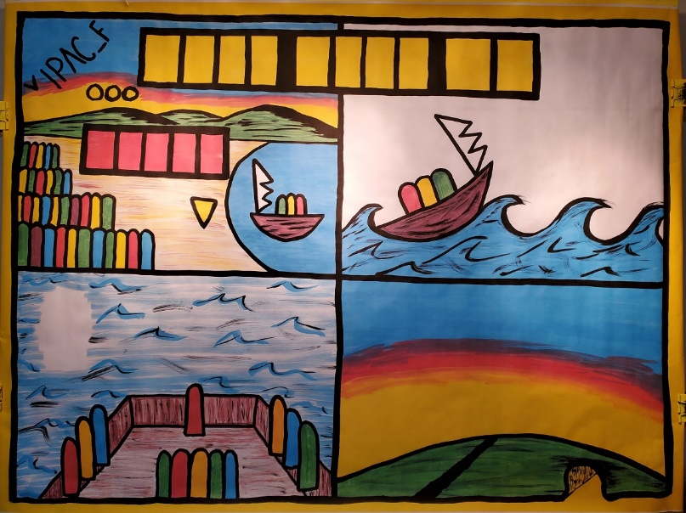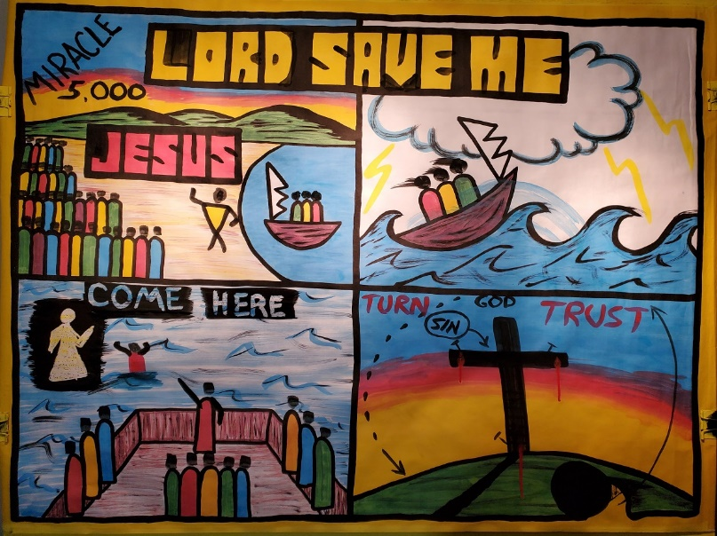

The Early Life of Jesus

Day 5: Jesus Feeds the Five Thousand / AKA: “Lord Save Me”

Mark 6:30-56
Note: When you see typing in “CAPS” like this, make sure you are drawing on the sketch-board as you teach

Introduction: How many here today has ever missed breakfast? How many here has ever missed breakfast and lunch in the same day? If you have, you know how hungry you can get. One day Jesus was teaching, and the people stayed all day to listen to him and missed breakfast and lunch.

Tell the story in your own words…

Top Left Picture:

- Paint in the word JESUS and Jesus’ HEAD (yellow figure by the water) 1). Jesus had been doing amazing miracles and people followed him

- Paint word MIRACLES
1). Jesus showed He is Lord God by his miracles.

- Paint the numbers: 5000

- Paint on HEADS ON CROWD
  - Hungry crowd, 5000 men
  - Plus women and children, it could have been 10,000 people 3). Jesus asked Philip –where to buy food to feed the people 4). 5 loaves 2 fish
5). Jesus thanked God broke the loaves and fed people 6). Gathered 12 baskets of food (point to the word miracle)

- Paint the word LORD in the title

1). Jesus showed again by this miracle that He is the Lord God.

Transition to next box:
- Jesus sent the disciples to the other side of the Sea of Galilee.
- Jesus went up the mountain to pray.

Top Right Box:

- Paint in HEADS on the boat 1). 3 miles out, storm

PAINT WAVES crashing on the boat
- What happens when there is a strong wind on water?
- Fierce storm. Scared of drowning.

Bottom Left Box:

Disciples in ferocious storm

- Paint in 12 BLACK HEADS
- 4:00 o’clock - “It’s a ghost”

- Paint over the WAX JESUS ON THE WATER
- Jesus said “Take courage, it is I; do not be afraid”
- Peter said “Lord, if it is you, command me to come to You on the water” Jesus said ….

j). Paint in the word COME!

K). Paint BLACK STICK FIGURE of Peter on the water.
- started to sink. Huge waves and Peter got scared L). Paint Peter halfway with water using BLUE PAINT
- Peter didn’t turn to his friends in the boat, but turned to Jesus and cried out: Paint in LORD SAVE ME in the title.
  - Jesus grabbed Peter and got in the boat.
  - The storm stopped. “Miracle”

Transition to next Box:
  - Just like Peter called out LORD SAVE ME….
  - We do not need to be saved from water but our sins against God.

Bottom Right Picture: Gospel message

  - Saved from sin - lying, stealing etc. go through some of the 10 Commandments
  - We don’t deserve Heaven
-The punishment for our sins is death (Romans 6:23).
  - Jesus was perfect, God’s son.
  - John 3:16

- Draw the CROSS
  - “For the wages of sin is death but the free gift of God is eternal life”
  - Sinners earn death and separation from God forever in Hell.
  - GOOD NEWS Jesus died in our place, for our sins.

- Press red brush hard into the cross, and the RED PAINT DRIP to symbolize the blood of Jesus.
  - Without the shedding of blood there is no forgiveness (Hebrews 9:22).

Paint BLACK NAILS and CROWN OF THORNS

- Jesus rose from the dead. Paint in YELLOW LIGHT coming from the grave.
Also, paint in BLACK ARROW GOING UP.
  - Jesus rose form the dead
  - Showed Himself to his disciples that He was alive. Then went to Heaven.
  - Jesus said: “I am the way the truth and the life… Our response to the Gospel:
- Paint in red TURN
  - Turn or repent. Repentance means to think differently:
    - If you think you are good, repent!
    - If you think you are not a sinner, repent, think different.
    - If you think Jesus is not God, repent!
    - Turn to Jesus as a sinner and find forgiveness.

- Paint in red TRUST
  - Trust in Jesus to save from your sins. Only Jesus can forgive you.

Conclusion:
Close with a minute of silent prayer, and allow the children to talk to Jesus in their own words. Then afterwards, ask them in counseling what they prayed to Jesus. If they said they told Jesus they wanted to be good, then they did not understand the gospel. If they say they wanted Jesus to forgive them, then possibly they truly trusted in Christ as their Savior.

Teachers Note: If this outline seems like a lot, what is most important is telling the story and sharing the gospel accurately. If you miss something on the paint-board, don’t get frustrated, just keep going and do your best to share who Christ is, and what He did for us!

