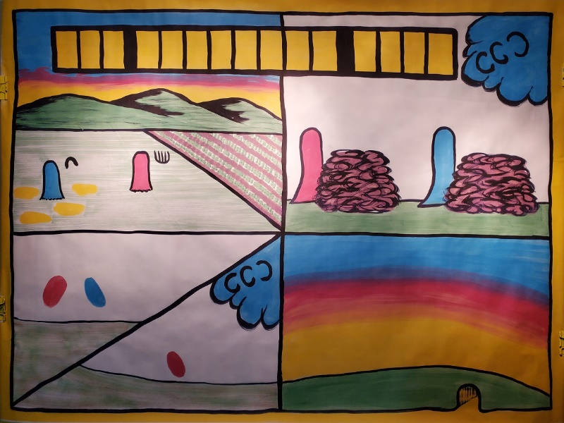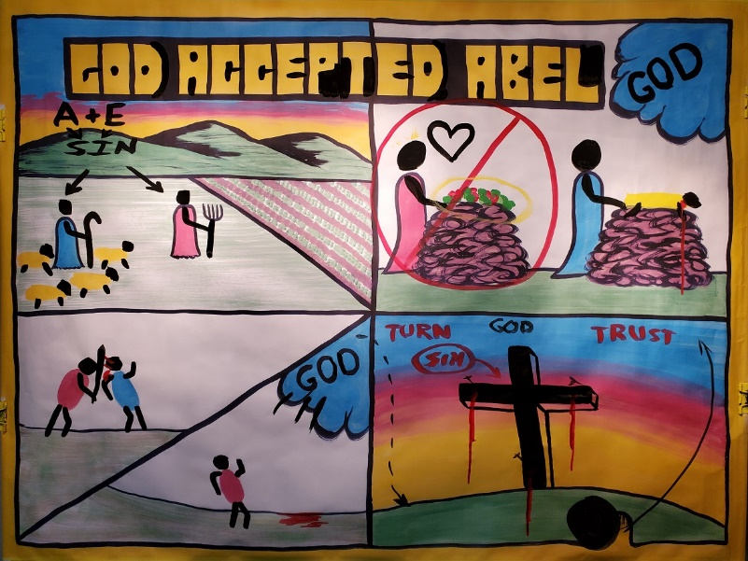
Creation Series
Day 5: God Accepted Abel / Gospel Message
(Genesis 4)
Note: When you see typing in “CAPS” and bold like this, make sure you are drawing on the sketch-board as you teach
Main ideas!

- The wages of sin is death
- No one can be good enough for God
- Someone has to die to pay for our sins.
- Jesus Christ, like a lamb, died in our place (Gospel Message) and rose again.

Introduction: Today we are going to talk about one of the most important questions ever: How we can be ACCEPTED by GOD (write in the title).

- Adam and Eve are now living outside of the Garden of Eden.
1). Life is difficult with pain, thorns, weeds, and disease 2). We are living outside of the Garden of Eden.

- Adam and Eve had children.
  - They had two sons: Cain and Abel
  - Cain was a farmer (draw in HEAD AND ARMS and a PITCHFORK). 3). Abel was a shepherd (draw in HEAD AND ARMS and a STAFF).

- Adam and Eve had sinned. Do you think their children were born good or born sinful? (Wait for an answer).
- The Bible says A + E SIN was passed down (DRAW ARROWS) to their children. (Romans 5:12)
- As they grew up, they sinned just like their parents.
- How many sins does it take to be in trouble with God? Only one.

Therefore, either they have to die for their sins, or, someone else can take their place.

Top Right Box

- Adam and Eve must of told their sons about how God killed the animal and clothed them with a covering of skin (this is implied from the text)
- Cain and Abel now are going to have to make a sacrifice for their own sins.
- Cain and Abel come to God with a sacrifice (DRAW HEAD AND ARMS ON CAIN AND ABEL).
- Cain put VEGETABLES on the altar.
- Abel put some of a KILLED ANIMAL on the altar (DRAW BLOOD).
- Which sacrifice did God accept? (Wait for an answer).

- Draw in the title: God Accepted ABEL
- God accepted Abel, but rejected Cain (DRAW A RED LINE through Cain's sacrifice).
- Why did God accept Abel, but not Cain?
- “Without the shedding of blood there is no forgiveness” Hebrews 9:22
- Abel's sacrifice showed God that sin is serious. Someone had to die for his sins. Abel was showing God that he deserved to die for his sins. But by faith, Abel was trusting God that through a substitute dying for him, God might show mercy.
- Cain's sacrifice showed that he didn't care. He came his own way, not God's way.

Bottom Left Box

- Cain became very mad that God accepted Abel, not him.
- Whose fault was it?
- God actually reached out to Cain by telling him that if he came God's way, he would be accepted as well.
- Instead, Cain got mad and jealous.

- Start to draw in the ARMS and SWORD of Cain.
1). Cain took out his anger and attacked and killed his brother (Draw BLOOD) 2). This is the first murder in the Bible.

- GOD came to Cain and asked where his brother was.
- Cain gave God an attitude (DRAW AN ARM OUT TOWARD GOD).
- Cain said, “Am I supposed to be taking care of my brother all the time!” 3). God said, “You killed your brother. His BLOOD is on the ground.
- God made Cain leave his family and be an outcast.
- Now Adam and Eve are alone again. One son is dead, and the other was made to leave.

- This is a sad story. However, it shows how God accepts and forgives sinners. 1). Do you want to be like Cain or Abel?
2). Just like the title, you want it to say: “God accepted .” 3). We need someone to die in our place for our sins. Do we bring a lamb?
Let me tell you what God did for us.

Bottom Right Box

Transition to the Gospel:
Are we okay with God, the way we are right now? No.
Here are some reasons why:
- Have you ever told a lie? If so, then in God's eyes we are liars.
- Have you ever stolen anything? If so, then in God's eyes we are thieves.
- Have you ever disobeyed your parent? If so, then in God's eyes you are rebellious. This is as much, or more sin than Adam and Eve did.
God also tells us "For the wages of sin is death (Hell and separated from God forever) but the free gift of God is eternal life." God is telling us here that because we sin, we earn death and separation from Him forever in Hell.
We have a problem. We can take our punishment, or, we can find someone else to take our punishment for us. Do you know anyone that would do that for you? I do.

DRAW IN THE CROSS AND NAILS
Jesus, God's Son came to earth and lived a perfect life. Jesus never once told a lie. Jesus never once stole something. Jesus never once disobeyed or disrespected His earthly mother. Jesus is holy and perfect because He is God in the flesh. Jesus chose to die, because either we get punished for disobeying God, or someone else like Jesus would give his life and die in our place, for our sins, so we don’t have to. John 3:16 says: "For God so loved the world that He gave His only begotten son, that whosoever believes in Him will not die but will have everlasting life."
Because Jesus was perfect with no sin, He could take our death penalty for us. Jesus died in our place on the cross 2,000 years ago. Jesus allowed Roman soldiers to nail spikes through His hands and feet to nail Him to the cross. God tells us…

Now take your red paint and press firmly on the cross where Jesus' hands and feet would be so that red blood pours down the page
“Without the shedding of blood there is no forgiveness. “ (Hebrews 9:22)
Abel brought a lamb to die in his place. Jesus God's Son, was like a lamb and chose to die like a lamb in your place. So, you don't have to sacrifice anything for God, because Jesus was your sacrifice for you.

BLACK ROCK MOVED FROM THE TOMB.
  - YELLOW PAINT FOR LIGHT
  - ARROW GOING UP
Jesus rose from the dead, He conquered death, and is alive today. He is in Heaven, awaiting all who will trust in Him as their Savior.

Paint in word TURN
Turn to Jesus to be saved. Many people turn to other things to save them. Some think going to church or being baptized will save them. Turn away from things that will not save you, and turn only to Jesus to save you.

Paint in the word TRUST
We must trust in Jesus to save us from our sins. Other words for TRUST are to believe.
If we trust or believe in Jesus to save us from our sins. We will be accepted before God, just like Abel was.

Conclusion: Have the children pray in their own words to Christ to be saved.

