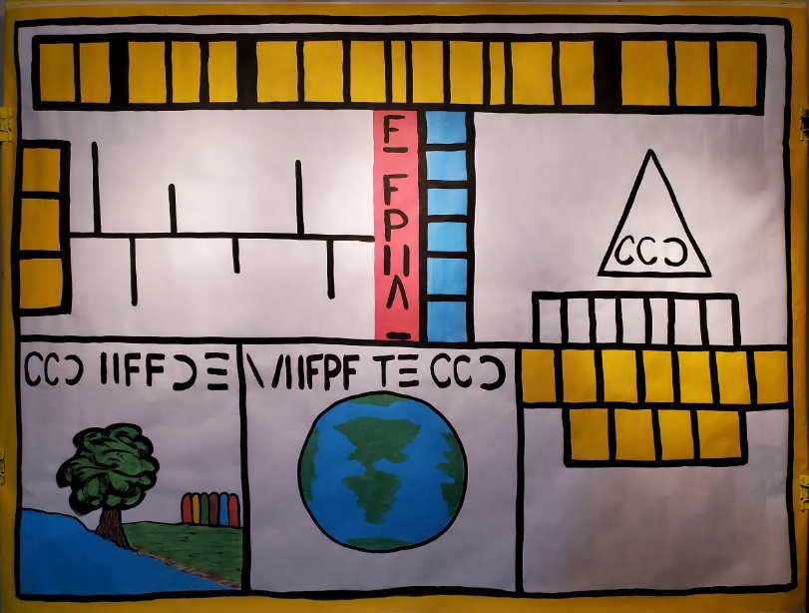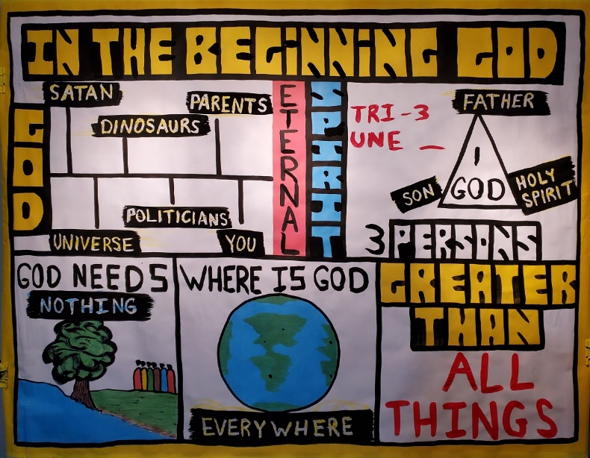
Creation Series
Day 1: What is God like?
Note: When you see typing in “CAPS” and bold like this, make sure you are drawing on the sketch-board as you teach
Main Ideas:
- To teach theology (the study of God)
- Children and adults cannot trust in God, unless and they understand first who God is, and what He is like.

Say: “The first Bible verse in the Bible is...” IN THE BEGINNING GOD (Draw in the title)

UPPER LEFT BOX

- God was here before all things:
  - The Bible says that in the beginning God created the heavens and the earth (Genesis 1:1). Therefore, GOD was here before all created things
    - Was God here before the UNIVERSE? (wax) Yes, because He created the universe.
    - Was God here before the ANGELS (wax)
    - Was God here before the TIME (wax)
    - Was God here before the ANIMALS (wax)
    - Was God here before the PEOPLE (wax)
    - Was God here before US (wax)

The Bible says God was here before all things. God is the Creator, and we are His creation.

Is God in everything? No, God is not the same thing as His creation. God makes apples, but God is not an apple. God makes the sun, but God is not the sun. God makes wind, but God is not the wind etc.
- How many people here have a birthday? Ask: What is your birthday?
God never had birthday, because He was never created. God has always been alive. God never had a Mom or Dad. The word we use to describe that God never had a beginning, and God will never have an end is the word: ETERNAL
(Psalm 90:2) UPPER RIGHT BOX
C): What color do you think God is? None.
1). God is SPIRIT (John 4:24). God does not have a physical body.

- How many Gods are there?
1). There is only 1 God (1 Tim. 2:5).

- Is God a thing, a force, or a person? God is a real PERSON that can talk and think.

In fact God is different from us in that God is actually 3 persons (Matthew 28:18-20).
1). God is God the FATHER (paint over in wax) 2). God the SON (wax)
3). God the HOLY SPIRIT (wax)

How many of you have seen a tricycle? There is only one bike, but three wheels. The word TRI means three. UNITY means one. Therefore, Christians call God a Trinity because God is three persons, but yet is one God. God is one God, but three persons. (Don’t a lot of time on this. Declare it, and move on).

LOWER LEFT BOX

- What do we need to survive?
  - We need water.
  - We need FOOD (draw in red apples) 3). We need the sun to keep us warm.

- What does God need? (Psalm 121)
1. God needs NOTHING (wax)

Does God need us? No. God was always here. Even before He created people. And God was never alone because God is three persons.

MIDDLE LOWER BOX

- WHERE IS GOD? If someone prays in America (draw in a red X), and someone prays in France (draw in a red X), and someone prays in China (draw in a red X) all at the same time, how does God hear all their prayers?
1). Because God is EVERYWHERE (wax)
How is this possible? Because is Spirit, and is not contained and limited to a body (Psalm 139).

LOWER RIGHT BOX

I). Can anyone think of anyone or anything that is greater than God?
God is...
1). GREATER THAN ALL THINGS (Isaiah 46, Psalm 147)

Conclusion: God is Creator, eternal, spirit, a Trinity, needs nothing, everywhere, and all-powerful.

