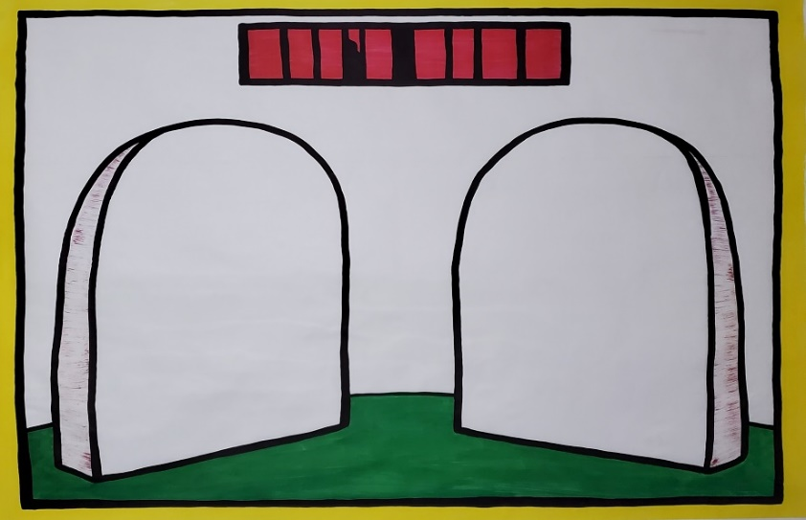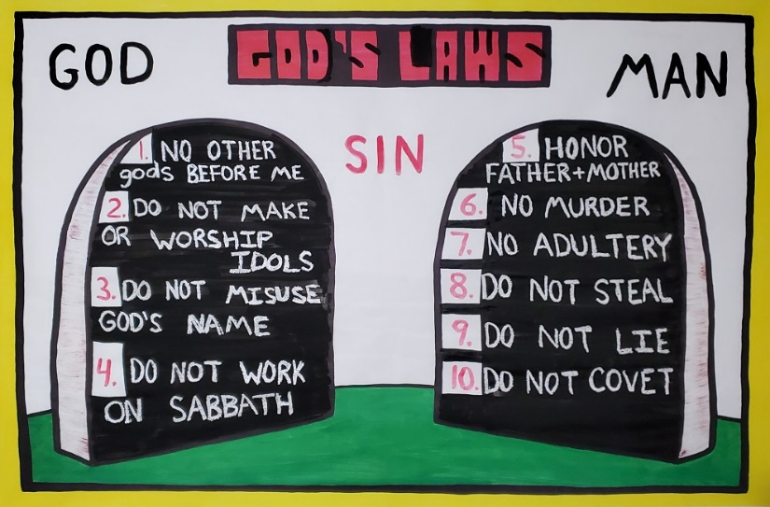
T H E T E N C O M M A N D M E N T S
Exodus 20
Starting with the last Commandments and working "up" to God

Introduction: Kids, let me ask you some of the most important questions you may ever be asked in your life.

- Do you believe in God?
- Do you believe in Heaven?
- How do you hope to get there?

Now, take that question and think about it for a moment. Make sure you have a solid answer in your mind.
Do you have it? Could you write it down? Now, if the answer you have is something like this:

A). I'm a good person B). I do my best
C). I help others D). I go to church
E). I keep the Commandments of God F). I've been baptized
G). I try love others and God

If you answered this way, you have not yet understood how to be accepted by God. You have not yet seen how Holy God is, and how sinful we are. Therefore, Heaven would not be your home. This is very serious. To help you out, today we going to talk about how Holy God is, and how "good" we really are by looking at the Ten Commandments to see how well we do. Let's start.

As you ask the question, paint over the commandment with your black brush, highlighting the wax.

- Commandment #9: Have you ever lied before? What do you call someone who lies? ( a liar)

- Commandment #8: Have you ever stolen anything? What do you call someone who steals? (a thief)

Would you consider a liar and a thief to be a good person? God considers lying and stealing to be sin.

"...sin is the transgression of the law." 1 John 3:4kjv

- Commandment #5: Have you ever disobeyed your parents? Has your parents ever had to raise their voice at you and punish you for your behavior. (If they say no, say, "How can I believe you, you just told me you were a liar and a thief.")

- Commandment #6: Have you ever murdered anyone? (They will obviously say no) 1 John 5:15 "Whoever hates his brother is a murderer, and you know that no murderer has eternal life abiding in him" Also: Matthew 5:21-22

- Commandment #10: Do you know what coveting is? The 10th Commandment says, You shall not covet...which means desiring something that doesn't belong to you: another person’s toy, book, video game, clothes, good looks etc. Stealing and greed are always linked to coveting. Coveting is really telling God you are not happy with what He has given you.

- Commandment #7: Do you know what adultery is? Adultery is when a man or a woman cheats on their spouse. Like if a husband went out got together with a woman who is not his wife. Or, if a wife went out and got together with a man who is not her husband. Adultery can also be when a teenager or young adult has physical intimate relationship with someone before their married. God has made sleeping in the same bed together and having children only for when a man and a woman is married (Let the kids get all their laughter out before proceeding).

How do you think you're doing so far? Do God will let a liar, a thief, and a murderer into heaven? For that is what we are.

"For the one who keeps the whole law and yet stumbles at just one point is guilty of breaking all of it." James 2:10

- Commandment #3: Have you ever taken God's name in vain? Have you ever used the name of one who gave you life to display disgust and use it with a curse word? God says that, "the Lord will not hold him guiltless who takes His name in vain." Exodus 20:7

- Commandment #4: Do you rest one day a week and honor God on the Sabbath day? Do you do this perfectly without flaw?

- Commandment #2: Do you ever, or have you ever prayed or worshiped an idol? The third commandment says we should not even make or have an idol for Jesus said, "Worship the Lord your God, and serve him only." Matthew 4:10. An idol, a dead saint, etc., all take the place that only God deserves.

- Commandment #1: The first commandment says "You shall have no other gods before me." Exodus20:3 Having another god does not just means another deity you worship, but anything that puts itself ahead of God such as: money, yourself, and even your family.

When you broke the other commandments were you putting God first? Therefore, we break the first commandment constantly.

Jesus said that if we love God, we will keep His Commandments

- If we lie and steal, are we loving God?
- If we disobey our parents and teachers every day, are we loving God?
- If we covet what other kids have, are we loving God?
- If we fight and yell and hit other kids, or even our brothers and sisters, are we loving God?
- If we use bad words, or use God's name in vain, are we loving God?

So, what's the point? The point is, we don't love God and therefore we break the first and greatest commandment of not putting God first. Another word for this is rebellion. The breaking of any of God's commandments is a willful decision to be in rebellion against God. This is very serious. You may not think that disobeying your parents, or being bad to your brother or sister is a big deal, but God thinks it's a big deal.

If you break a rule at home, does your parents give you a reward, or a punishment? A punishment, that's right. What is God's punishment for breaking one or more of His laws?
"For the wages of sin is death…" Romans 6:23
Notice that is doesn't say, sins. Or that you have to murder or kill someone to be in big trouble with God. It says, sin. Singular. One sin. One sin is all it takes to be in trouble with God. So, the breaking of any of God's commandments puts you in the category of being a law breaker and a sinner.
So, let me ask you another very important question? How are you going to be forgiven?
(Let them think about it for a while)

What is your answer? Did you mention this list again in your mind? A). I'm a good person
B). I do my best C). I help others D). I go to church
E). I keep the Commandments of God F). I've been baptized
G). I try love others and God
Or, ESPECIALLY, did you say this to yourself, "I guess I will try to keep the commandments from now on."
If you said this to yourself, you must know that you have not understood the lessons up to this point. What God has been teaching the Israelites, and what God want us to know is that He is holy, and we are not. One sin makes us unholy for all our lives. We have to be holy to be with God. We are not holy. We are the opposite. We are sinful and can never please God. It is a lie to think we can please God. "No one is holy like the Lord…" 1 Samuel 2:2 We haven't pleased God, and we will not be able to please God in future. Because we have already broken God's law, what has God already said we deserve? That is right, death. Once we die, then there is judgement (Hebrews 9:27)

It's like being a home or school when you do something very bad. Your parents or teacher doesn't say, "Oh well, I will deal with this person someday in the future." No! There is discipline right away. In the same way, once we sin, God already has given us a punishment of death. So, to say you can do better next time is to not understand that once we sin, we have already blown it! WE are in big trouble with God.

The gospel can be preached in another lesson, or added on to this lesson to close the message. Is there any solution? Is there any way to be forgiven?
Thankfully, yes there is.

Because of all our many sins, either we die, or someone else dies in our place. The good news is, God has given us someone who was willing to die in our place, for our sins.

PREACH THE GOOD NEWS

O p e n A i r C a m p a i g n e r s • PO Box D • Nazareth • P A 18064
Phone: (610) 746-0508 Fax: (610) 746-0509 Email: usa@oaci.org Web: www.oacusa.org

