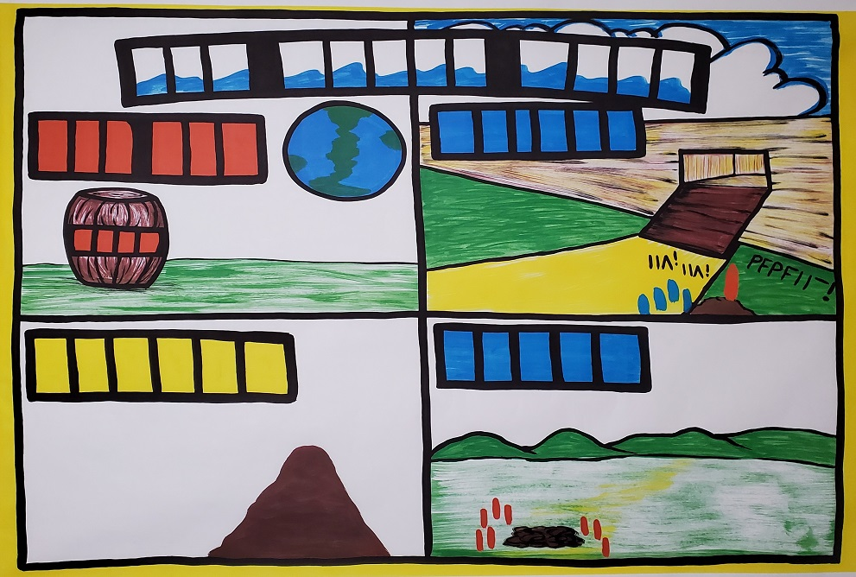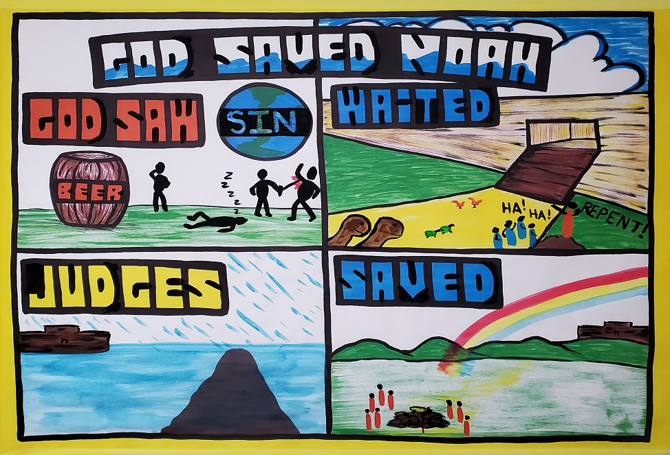

New Tribe Mission Outline Numbers

A-C

E.
The Abraham Series
Day 1: Noah

Sketchboard title: “God Saved Noah” Text: Genesis 6-8

Open Air Campaigners Outline

Introduction: When you think about God, what are the first words that come to mind? Some think of loving, and merciful. Others might think of holy and just. One thing we have to remember is God is not just one of these things, but all of them. God is loving, but He is also a judge. How can God be loving and judge at the same time? Today we are going to hear a very powerful true story that shows God as a God who gets angry with sinful people, but will also be merciful to those who trust Him.

Upper Left Box

After Cain and Abel were born, Adam and Eve had more children, and their children had children until, many years later, the earth had over a million people living on it.

Do you think the people after Adam and Eve were basically good and followed God, or, turned away from God and sinned?

After Adam and Eve sinned, all people born after them were born sinful.

- The World (draw in “sin” and explain that the world was full of sin - every person’s thoughts were sinful all the time.)

God allowed men do bad things like killing, laughing at God, and drinking.

- Draw in the people drinking, sleeping drunk, and killing

Did God care about what was going on? Yes, He did. Because…
F.
- Draw in the words, “God sees”

Because God sees every person, God knows what people say, think, and do. God saw all the wickedness on the earth, and God still sees all that people do today to one another (Proverbs 15:3)

Not only were the people of Noah’s day bad, but the Bible says about the people that, “every inclination of the thoughts of his heart was only evil all the time.” Genesis 6:5

And it says that the earth was full of violence (Genesis 6:11).

Therefore, God was grieved that He had made man. Not only was God grieved, but God was also angry with the people He had made for how they treated Him, and how they treated one another. Remember it was so bad at this point in history, that it was only constant evil from the people. What was God going to do? Ask them to behave?
Do better next time? No. God is not a God we can rebel against without consequences. This is what God said…

- “I am surely going to destroy both them and the earth.” Genesis 6:13
God decided to destroy the world with a flood to demonstrate that God judges sinners. The flood was going to be so big it would flood the entire earth. Did this mean that all the people would die for their sin? Well, what is God’s punishment for disobeying Him? What was God’s punishment to Adam and Eve? Death. (Romans 6:23)

- However, there was one man that found favor with God (Genesis 6:8). His name was Noah.

- Draw in the name “Noah” in the title

Since Noah was related to Adam, he was a sinful person like we all are, but, Noah was a man that trusted God, and God chose him to be the one survive the flood and repopulate the earth once the flood was over.

Noah was not alone. Noah was married and had three sons who were married. So, there was a total of eight people all-together that God chose to survive the flood (Genesis 6:10,18).

How was Noah and his family going to survive a world-wife flood?

Upper Right Hand Box

God told Noah to build an Ark (an ark is a big boat). Even though the
- world would be flooded, God would save Noah, his family and a portion
of each of the animal species. To bring male and female of each kind of animal, the Ark would have to be huge! So huge in fact that it would be longer than a football field with three decks inside. How long would it take eight people to build a boat that big so long ago without any power tools (Have the children guess)? It took Noah 120 years to build the ark!
J.

During that time God…

- Draw in the word “waited”

God did not destroy the people right away, but waited and was patient. While he was building the huge ark, many people came to watch.

- Draw in the people around the ark.

The people must have laughed at Noah for building a huge boat out in the middle of nowhere! What do you think Noah did in response?

Noah preached to them and told them to get ready for God’s judgement upon them (2 Peter 2:5)!

- Draw in Noah preaching to them (“Repent!”)

During those 120 years God was waiting, and being patient with people. Why? God was giving people time to admit their sin, realize they deserved judgment, and that God was offering them a way of escape through the ark. All they had to do was believe (2 Peter 3:9).
  - Finally when the ark was ready, God sent the animals to the ark.
- Draw in the animals coming to the ark.

  - There was only one way to be saved, and that was by one Ark through one door.

  - When they were all safely inside, God shut the door of the ark.
- Draw in the door being shut (Not in the drawing. Use brown paint)

The people outside of the ark waited and the probably had a good laugh. Then the rain started.

- Draw drops of rain (using blue paint) coming down from the sky (Not in drawing)
- The earth opened up with floods of water (Draw water shooting up from the earth. Not in drawing.)

Lower Left Hand Box

It rained for forty days and forty nights.

- Draw the water drops coming down from the sky.

It rained so much that the entire earth was covered with water.

- As you are saying the above statement cover the bottom half with blue paint illustrating water.

It rained so much that even the tallest mountain peaks were covered with water.

N.

Lesson 14

B-C
- Draw in water covering the tallest mountain peak.

Only Noah and his family were saved because they had trusted God. Everything else that had the breath of life in it died (Genesis 7:21-24).

- Draw in the word “Judged”

- Color in the large brown box on top of the water to illustrate the Ark.

(Interesting note: People find fish fossils on top of Mt. Everest! This is evidence of a global flood.)

Lower Right Hand Box

After living on the ark for a year, the waters went dried up and the ark landed on a mountain somewhere in the Middle East (Genesis 8:4).

- Draw in the ark on top of a mountain.

Noah and his family, along with all the animals left the ark to live on the earth and to repopulate the earth with people.

- Draw in eight people around an altar.

Noah’s family was very happy. Why?

- Draw in the rest of the title, “God Saved Noah”

They were happy because God was faithful to them even though they didn’t deserve it. God had saved them with the Ark. They sacrificed an animal on the altar to thank God for saving them from death (Genesis 8:20).

- Draw in an animal on top of the altar sacrificed.

The animal reminded Noah and his family that they should have died along with the rest of world, but God had mercy on them and saved them.

- Draw in the word “Saved”

Then God did something really special to remind all people that he would never again destroy the earth with a flood - He put a rainbow in the sky.

- Draw in the rainbow
D.
What is important to remember in this true story? First, that each one of us are accountable to God for our sins. And, God does judge sinners.
This is very real. But, we can be like Noah and realized that we need to be saved from our sins and trust God for the way He has provided for us to be forgiven and saved. What is that way? We will find out in the lessons to come.

END

Major points: This story is not about God saving animals. This is about God’s justice in that all sinners must be punished. However, it is also about God’s grace in giving people salvation if they believe His promises that He will save them. The Ark is a picture of the one way of salvation through Jesus Christ- we must trust and believe God to be saved from our sin.

